Name: Mriganka Patra

Email: [mriganka.patra@cognizant.com](mailto:mriganka.patra@cognizant.com)

Emp ID: 2415820

Day 18

Sprint 1 Submission

Objective: Implement the base CRM logic with record types, automation, visibility settings, and user management.

Task 1.5: As a data manager, I want to bulk upload Account records using the data loader so that initial data can be seeded efficiently.

1. Go to setup > home
2. 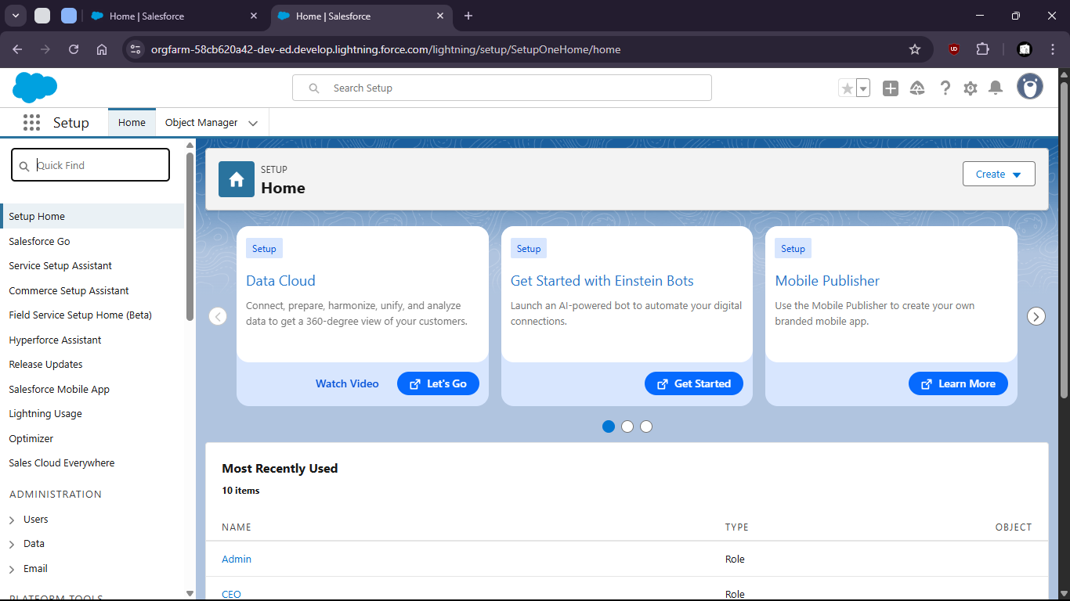
4. Search for data import wizard

7. 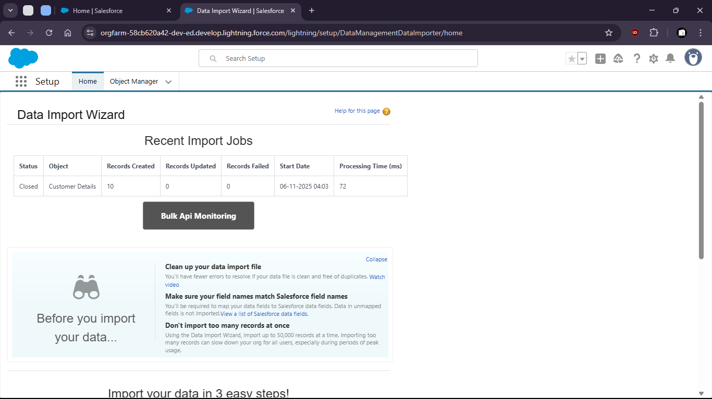

10. launch wizard

13. 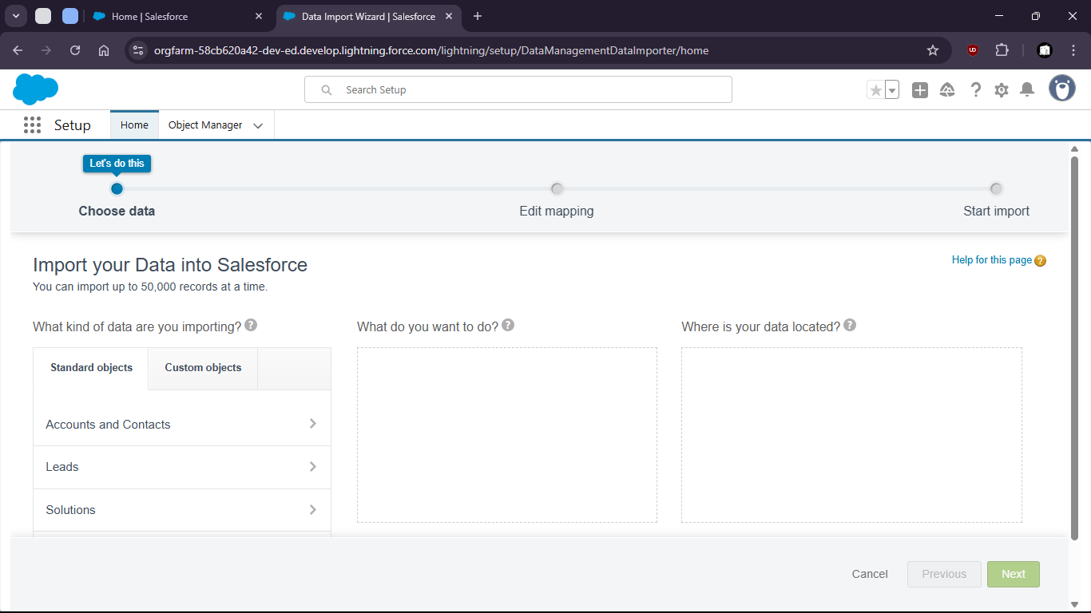

16. Select > Custom object > Customer Details > Add new Records > Upload the csv
18. 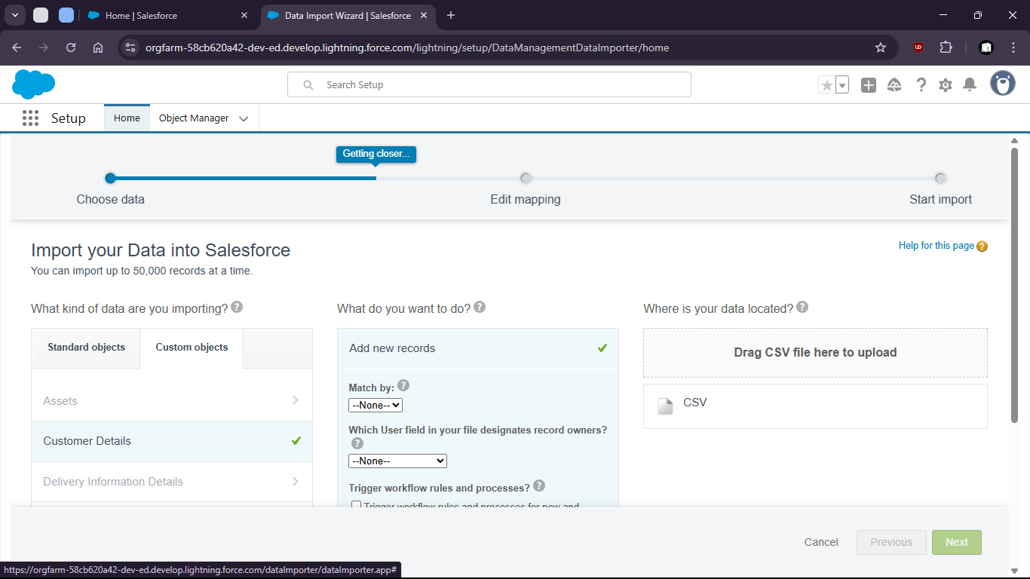
20. 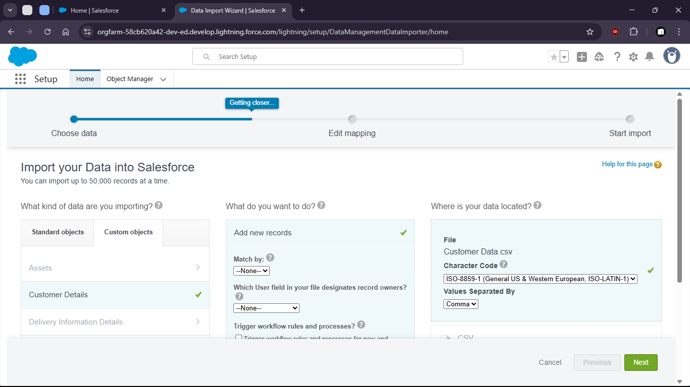

23. 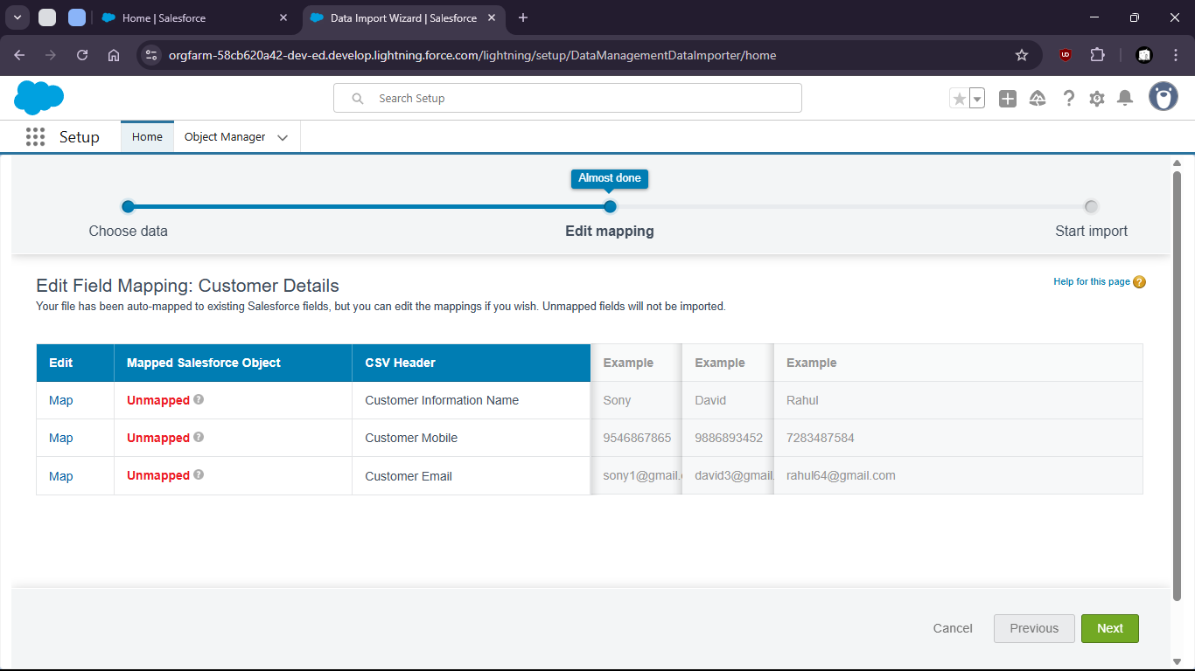
24. Now map the fields
26. 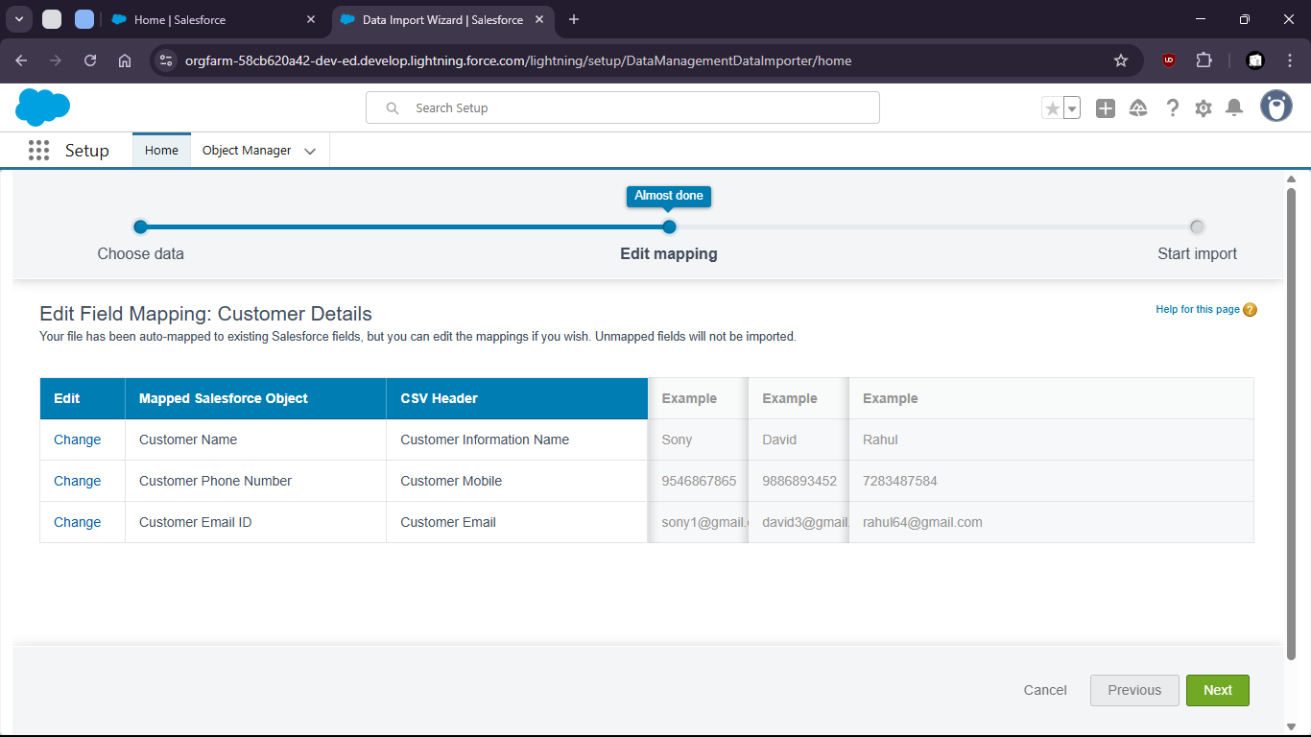
28. now start import
29. 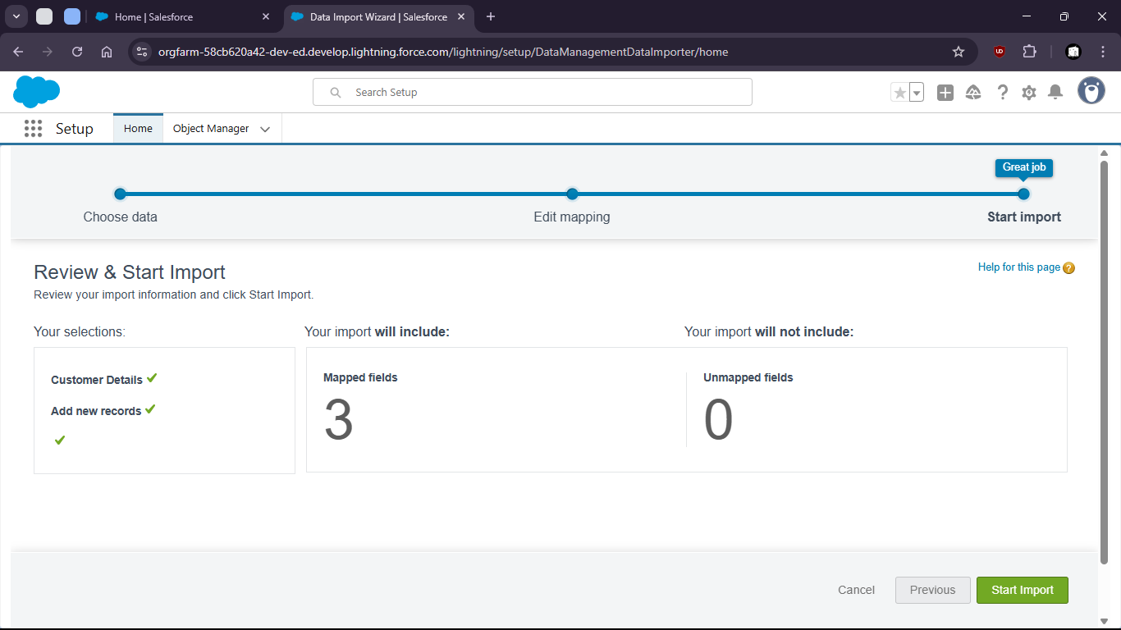

32. 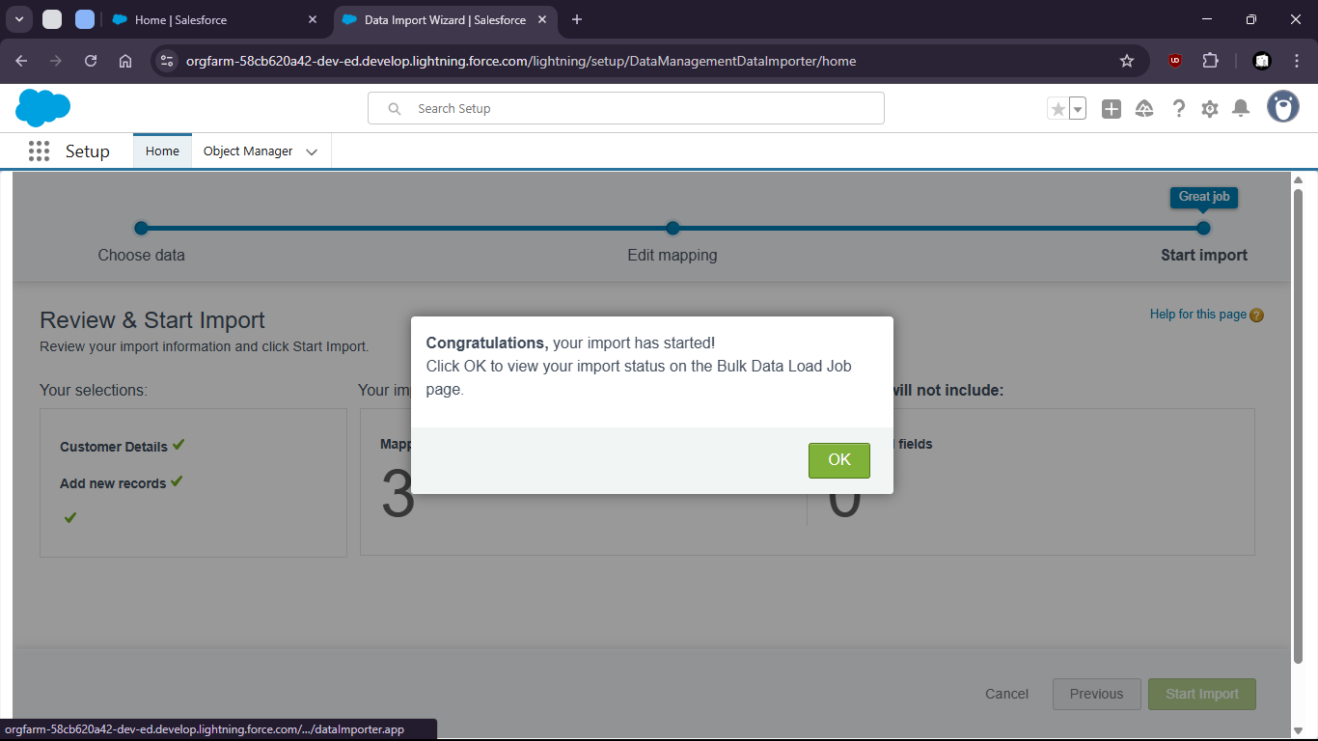

35. 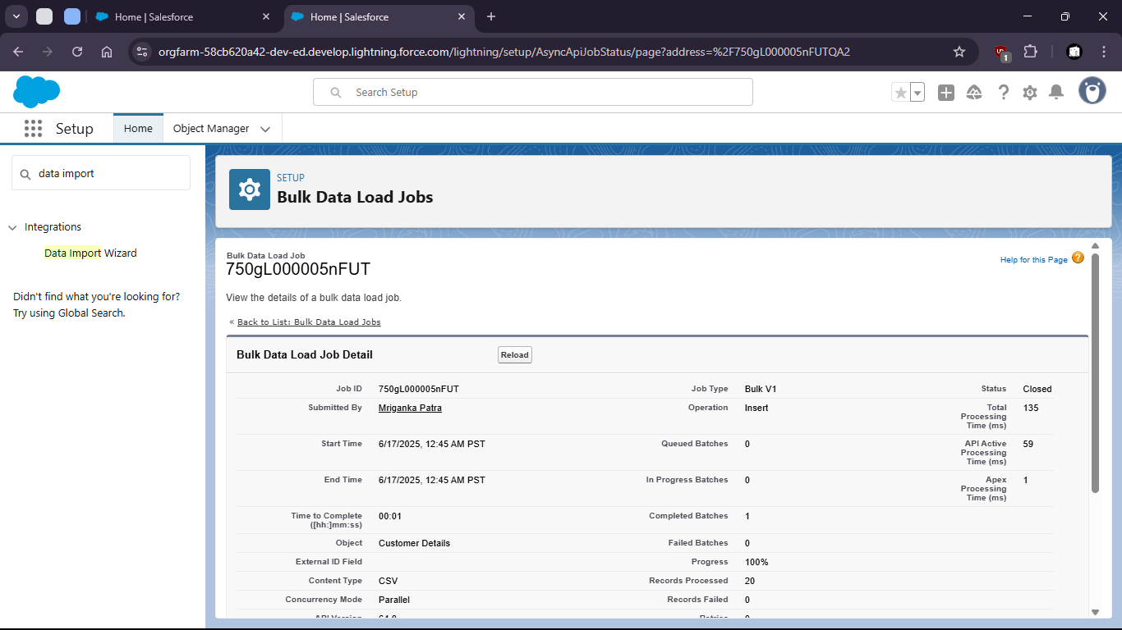

38. Now check for all customer details (if upload was successful)

41. 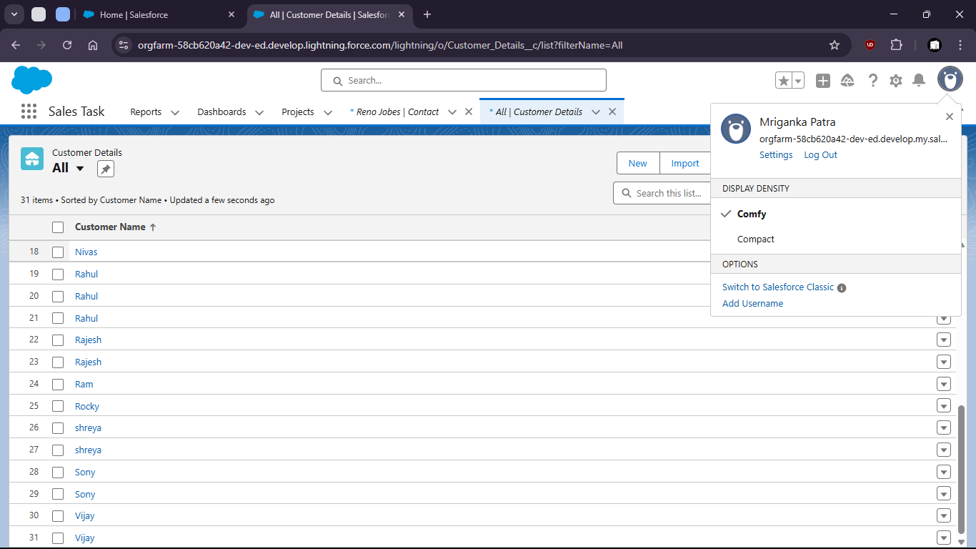
42. Uploaded csv file:
44. 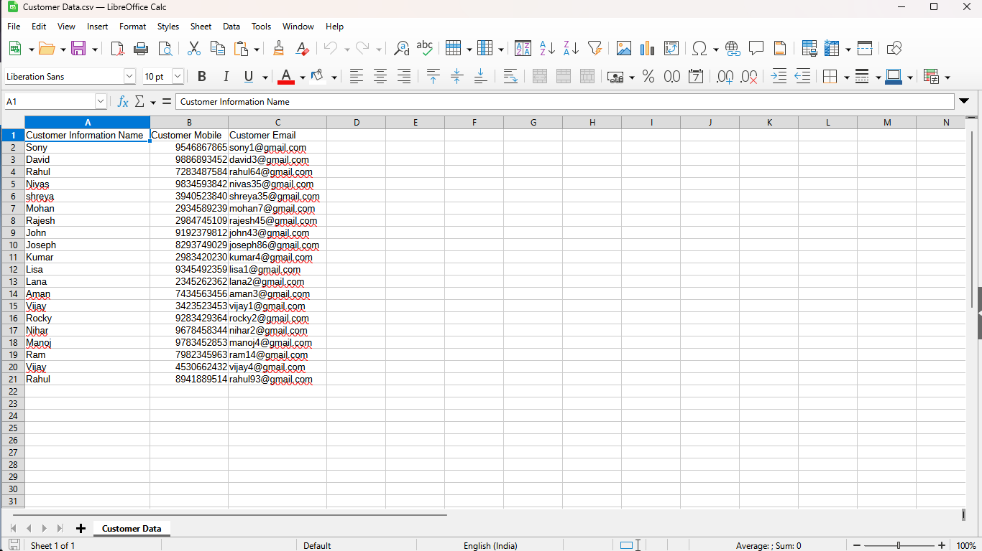
46. Validations
48. 